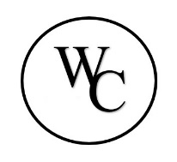
Western Ohio Regional Treatment & Habilitation Center

ANNUAL REPORT ON SEXUAL ASSUALT DATA: FY’23

Prepared by: Chuck Honigford LPCC-S Clinical Services Director, PREA Coordinator

I. Introduction

The WORTH Center collects data on all reported incidents involving sexual misconduct and sexual harassment
occuring at the facility and reports of incidents at other correctional institutions. This data is used to assess and
improve the effectiveness of the facility’s sexual abuse prevention, detection, and response policies, practices,
and training.

II. Data: FY’23

Allegations Substantiated Unsubstantiated Unfounded Total

Staff Sexual 0
Harassment

Staff Sexual 1 1
Misconduct

Resident on 1 1
Resident Sexual
Harassment

Resident on
Resident Sexual 1 2 3
Misconduct

III. Conclusion

The WORTH Center saw a decrease in reports from FY 2022 and continue to educate both residents and staff as well as investigate all allegations. The facility maintains a zero tolerance towards all forms of sexual abuse and sexual harassment.

